

**Abbottabad university of science & technology**

***HOSPITAL MANAGEMENT SYSTEM:***

**Submitted by : Fatima Bibi**

**Submitted to : Sir Jamal Abdul Ahad**

**Roll No : 14646**

**Course : Data structure & Algorithm**

**Submission date : January 31, 2025**

***HOSPITAL MANAGEMENT SYSTEM:***

***CODE:***

import heapq # Import heapq for heap operations

# Global Variables

Patient_ID = []

Patient_Name = []

Patient_Age = []

Patient_Gender = []

Diagnosis = []

Room_Assignment = []

Doctor_Name = []

Treatment = []

Billing = {}

# Heaps for room numbers

general_rooms = list(range(1, 51)) # 50 rooms

icu_rooms = list(range(51, 71)) # 20 rooms

emergency_rooms = list(range(71, 81)) # 10 rooms

# Convert to heaps

heapq.heapify(general_rooms)

heapq.heapify(icu_rooms)

heapq.heapify(emergency_rooms)

# Priority Queue for Emergency Cases

patient_queue = deque()

emergency_queue = deque()

# Doctor Availability

doctor_availability = {

'Dr. Imran': True,

'Dr. Fatima Shah': True,

'Dr. Abdul Qadeer': True,

'Dr. Rehan': True,

'Dr. Ahmad': True

}

# Illness to room and doctor mapping

illness_mapping = {

'fever': ('general', 'Dr. Imran', 500),

'cold': ('general', 'Dr. Fatima Shah', 300),

'heart attack': ('icu', 'Dr. Abdul Qadeer', 5000),

'stroke': ('icu', 'Dr. Rehan', 4500),

'accident': ('emergency', 'Dr. Ahmad', 7000)

}

def suggest_treatment(diagnosis):

"""Suggests a treatment based on the diagnosis."""

treatments = {

'fever': 'Paracetamol and rest',

'cold': 'Antihistamines and fluids',

'heart attack': 'Immediate surgery and medication',

'stroke': 'Clot-busting drugs and therapy',

'accident': 'Emergency surgery and wound care'

}

return treatments.get(diagnosis, "No treatment available")

def get_patient_id():

"""Get and validate the patient ID."""

while True:

pid = input("\tEnter patient ID (XXXX-XXXX): ").upper()

if len(pid) == 9 and pid not in Patient_ID:

return pid

elif pid in Patient_ID:

print("###### Patient ID Already Exists ######")

else:

print("###### Enter a Valid Patient ID ######")

def get_patient_info():

"""Get and validate patient information."""

name = input("\tEnter patient name: ")

age = input("\tEnter patient age: ")

gender = input("\tEnter patient gender (M/F): ").upper()

return name, age, gender

def get_diagnosis():

"""Get the diagnosis."""

diagnosis = input("\tEnter diagnosis (fever/cold/heart attack/stroke/accident): ").lower()

while diagnosis not in illness_mapping:

print("###### Invalid illness. Please choose from fever, cold, heart attack, stroke, or accident ######")

diagnosis = input("\tEnter diagnosis: ").lower()

return diagnosis

def assign_room_and_doctor(diagnosis):

"""Assign room and doctor based on diagnosis."""

room_type, doctor, cost = illness_mapping[diagnosis]

room = None

if room_type == "general" and general_rooms:

room = heapq.heappop(general_rooms)

elif room_type == "icu" and icu_rooms:

room = heapq.heappop(icu_rooms)

elif room_type == "emergency" and emergency_rooms:

room = heapq.heappop(emergency_rooms)

if room:

doctor_availability[doctor] = False

return room, doctor, cost

else:

print("###### No rooms available for this diagnosis. Try another diagnosis. ######")

return None, None, None

def add_patient():

"""Add a new patient entry."""

patient_id = get_patient_id()

name, age, gender = get_patient_info()

diagnosis = get_diagnosis()

room, doctor_name, cost = assign_room_and_doctor(diagnosis)

if room:

treatment = suggest_treatment(diagnosis)

# Store patient information

Patient_ID.append(patient_id)

Patient_Name.append(name)

Patient_Age.append(age)

Patient_Gender.append(gender)

Diagnosis.append(diagnosis)

Room_Assignment.append(room)

Doctor_Name.append(doctor_name)

Treatment.append(treatment)

Billing[patient_id] = cost

# Add patient to appropriate queue

if diagnosis in ["heart attack", "stroke", "accident"]:

emergency_queue.append(patient_id)

else:

patient_queue.append(patient_id)

print(f"\n###### Patient assigned to Room {room} under {doctor_name}. Treatment: {treatment}. Estimated Cost: Rs.{cost}. Entry Saved ######")

else:

print("###### Unable to assign a room. Patient not added. ######")

def process_patient():

"""Process the next patient in the queue."""

if emergency_queue:

pid = emergency_queue.popleft()

elif patient_queue:

pid = patient_queue.popleft()

else:

print("No patients in queue.")

return

print(f"Processing patient {pid}. Preparing for doctor's consultation and treatment.")

def discharge_patient():

"""Remove a patient and free up resources."""

pid = input("Enter Patient ID to discharge: ").upper()

if pid in Patient_ID:

index = Patient_ID.index(pid)

room = Room_Assignment[index]

doctor = Doctor_Name[index]

# Free the room

if room in range(1, 51):

heapq.heappush(general_rooms, room)

elif room in range(51, 71):

heapq.heappush(icu_rooms, room)

else:

heapq.heappush(emergency_rooms, room)

# Free the doctor

doctor_availability[doctor] = True

# Process payment

payment = Billing[pid]

print(f"###### Payment Processed. Total Amount: Rs.{payment} ######")

# Remove patient

Patient_ID.pop(index)

Patient_Name.pop(index)

Patient_Age.pop(index)

Patient_Gender.pop(index)

Diagnosis.pop(index)

Room_Assignment.pop(index)

Doctor_Name.pop(index)

Treatment.pop(index)

Billing.pop(pid, None)

print("\n###### Patient Discharged ######")

else:

print("###### Patient Not Found ######")

def search_patient():

"""Search for a patient by their ID."""

pid = input("Enter Patient ID to search: ").upper()

if pid in Patient_ID:

index = Patient_ID.index(pid)

print(f"Patient found: {Patient_Name[index]} - {Diagnosis[index]}")

else:

print("###### Patient Not Found ######")

import random

def check_doctor_availability():

"""Check if a doctor is available."""

doctor_name = input("Enter doctor's name: ").strip()

# Randomly decide doctor availability (True or False)

is_available = random.choice([True, False])

if is_available:

print(f"{doctor_name} is available for consultation.")

else:

print(f"{doctor_name} is not available at the moment.")

def view_patients():

"""View all patient records."""

print("\nPatient ID | Name | Age | Gender | Diagnosis | Room | Doctor | Treatment | Cost")

for i in range(len(Patient_ID)):

print(f"{Patient_ID[i]} | {Patient_Name[i]} | {Patient_Age[i]} | {Patient_Gender[i]} | {Diagnosis[i]} | {Room_Assignment[i]} | {Doctor_Name[i]} | {Treatment[i]} | ${Billing.get(Patient_ID[i], 'N/A')}")

def main():

"""Main menu loop."""

while True:

print("\n1. Add Patient")

print("2. Process Next Patient")

print("3. Discharge Patient")

print("4. View Patients")

print("5. Search Patient")

print("6. Check Doctor Availability")

print("7. Exit")

choice = input("Choose an option: ")

if choice == "1":

add_patient()

elif choice == "2":

process_patient()

elif choice == "3":

discharge_patient()

elif choice == "4":

view_patients()

elif choice == "5":

search_patient()

elif choice == "6":

check_doctor_availability()

elif choice == "7":

print("Exiting... Goodbye!")

break

else:

print("Invalid Option!")

if __name__ == "__main__":

main()

***CODE AND OUTPUT SCREEN SHOTS:***

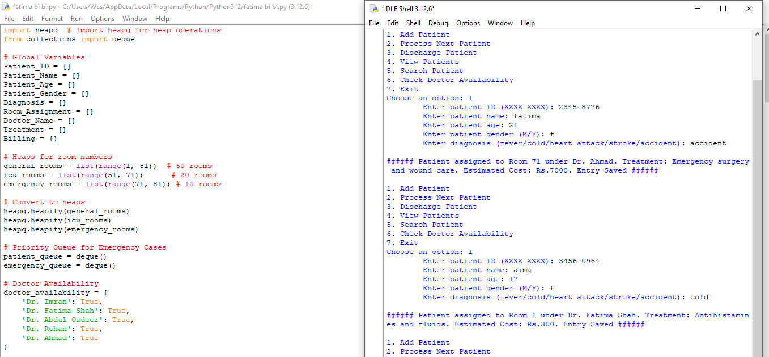

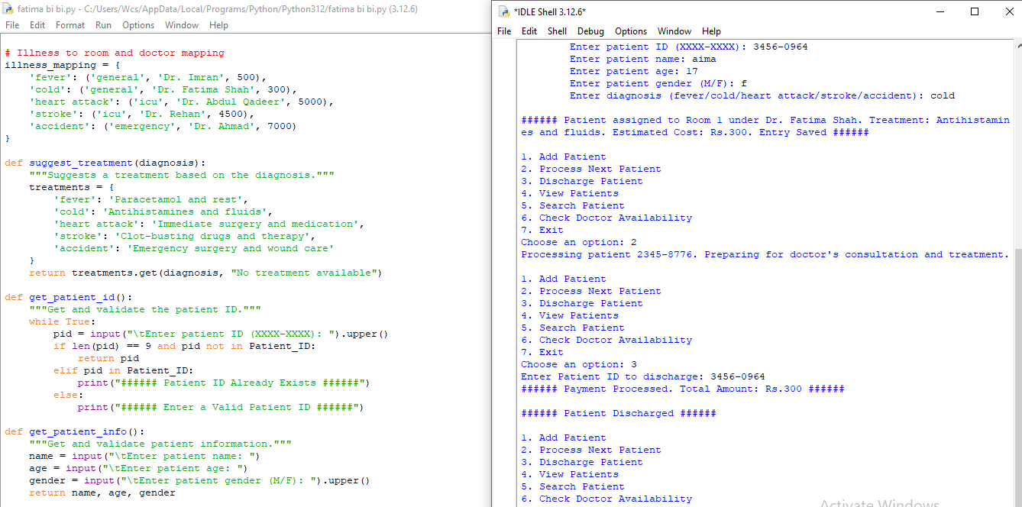

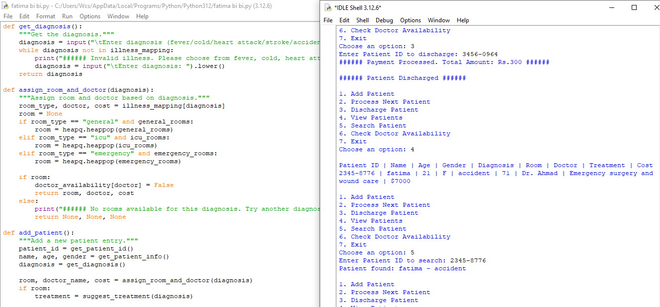

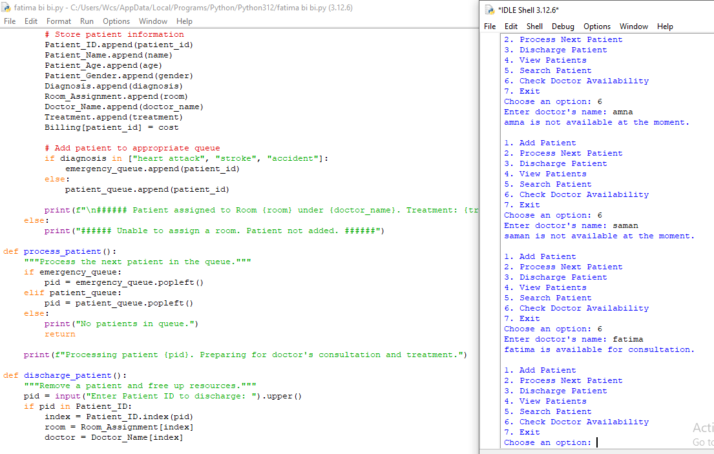

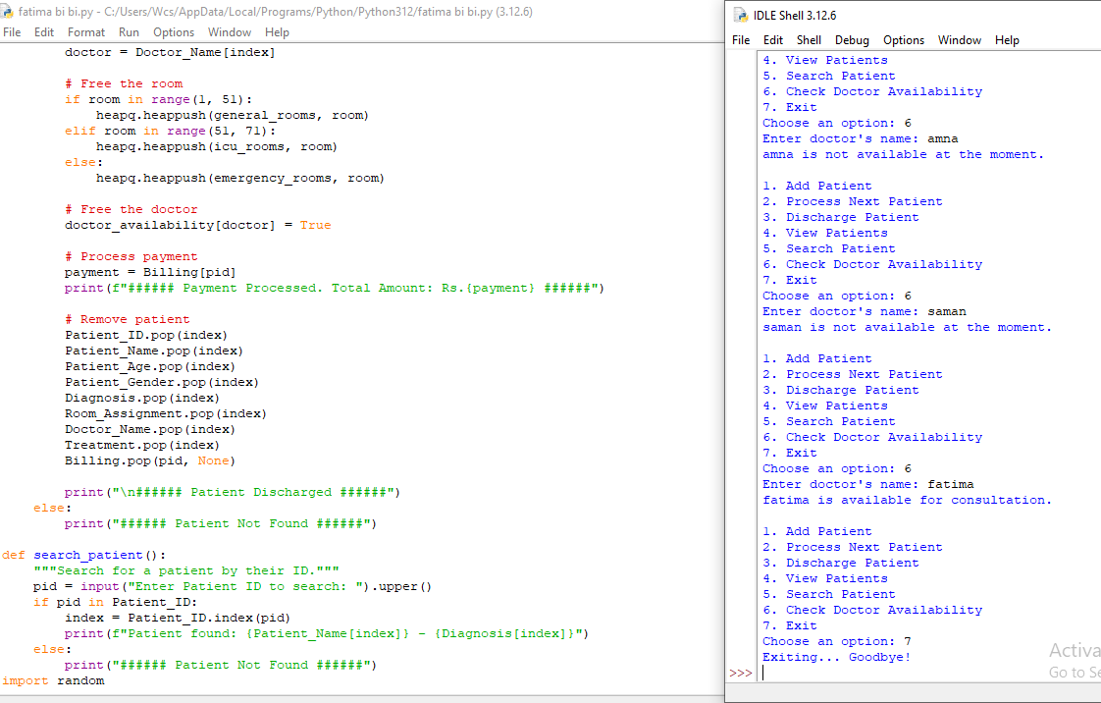

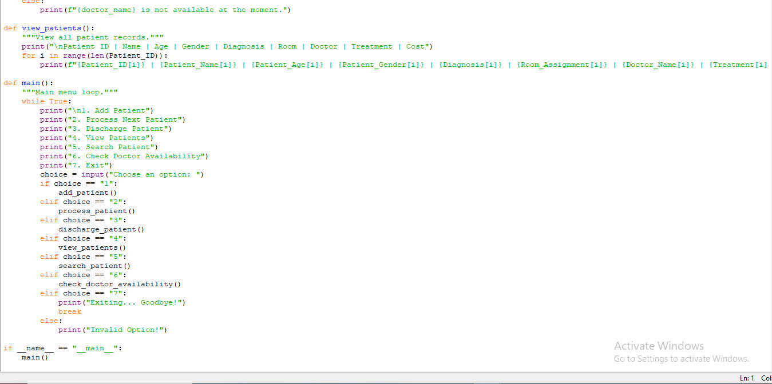

***OUTPUT :***

